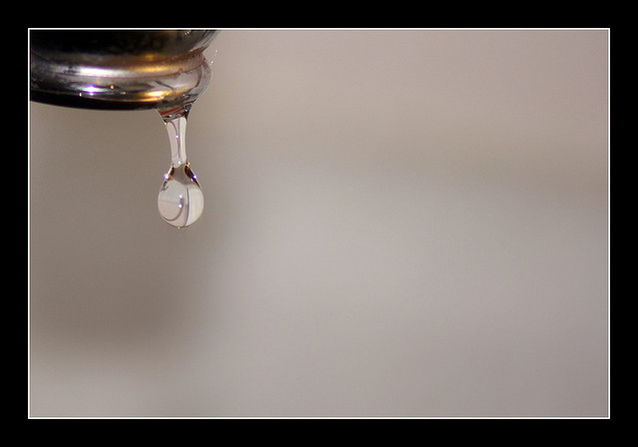  Drinking water is a precious resource to be used wisely. As your water purveyor, we work hard to eliminate leaks in the water distribution system. Many leaks occur inside the home. Finding and repairing leaks saves both water and money.  FACT: A dripping faucet, at a rate of 1 drip per second, will waste 2,082 gallons of water per year. Enough to fill more than 41 bath tubs. 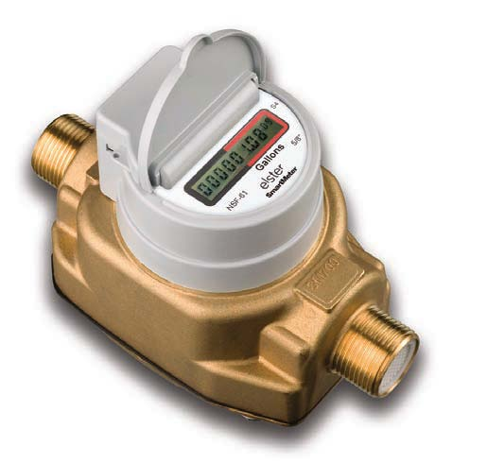 |  |  |  |  |  | Check for Leaks  Follow these steps to detect home leaks.  - Locate your water meter.  - Turn off all water (inside and out). Leave master valve open.  - Read your meter and write down the figure. The meter should have a small square blinking indicator for detecting leaks. If it is moving, there is a leak.  - To find out how large the leak is, wait 1 hour and read meter again. (Cu ft/hr)  - If the number has changed, there is a leak. The next step is to find it. Is it in your home, or in the service line?  - Turn water off at your master valve entering the house.  - Repeat steps 3 and 4.  - If the number changes again, the leak is in the service line. You can fix it yourself or contact a plumber.  - If the number doesn’t change, the leak is past the master valve and likely inside your home. In the case, check for leaks in toilets, faucets, etc.  Contact Us  Phone903-364-1016  Email: accounts@desertwsc.com  Web: www.desertwater.ruralimpact.com  DESERt WATER SUPPLY CORP.  5588 Hwy. 160  Whitewright, TX 75491 |  |  |  |  | 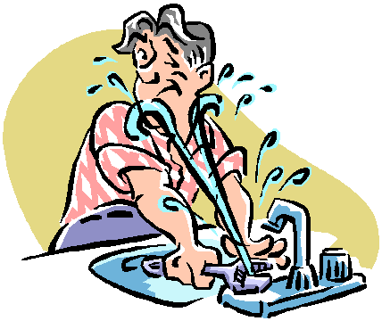  DESERT WATER SUPPLY CORPORATION
Every homeowner should be familiar with their home water system. Locate your water meter and your master water supply shut-off valve. Evaluate your water usage and make changes where you see waste. Contact your water purveyor for ways to reduce water usage in your home and landscape.  Your Water Meter  Your water meter is the best detective in your home. It can tell if you have leaks. All you have to do is learn its language. Find your water meter; it’s usually located near the street under a metal or plastic lid. To find out how much water you have used, subtract the number on your last bill from the current meter reading.  Reading the meter The reading is displayed on the totalizer module of the meter under a protective lid. The display digits before the decimal point, surrounded by a black or both a black and white border on the fascia, represent whole US gallons (gal) and the digits after the decimal point, surrounded by a red border, represent fractions of a gallon, ft3 or m3 . When water is flowing a flashing square icon appears to the lower right of the display, but when the flow has stopped this indicator will be extinguished.  Find Your Master Valve  The master water supply shut-off valve controls water flow into the home. Everyone in the house needs to know its location. You’ll need it fast in an emergency. You can’t afford to waste time searching while the basement floods. Locations may include:  - Where water supply enters the home, such as the garage or the foundation  - Near the clothes washer hookup  - Near the water heater  Once you find your master valve, tag it! |  |  |  |  |  | Fixing the 2 most common leaks – Faucet and Toilet leaks.  Fixing Faucet  You don’t have to be a professional to find or fix a leaky faucet. Leaks are commonly from a worn washer.  See steps below to fix a washer leak:  - Shut off water at nearest shut off valve.  - Loosen cap nut; then turn counter clockwise. Turn faucet handle in direction of opening until it come off.  - Lift out faucet assembly.  - Unscrew brass setscrew holding washer in place.  - Remove old washer. Flush or wipe cup clean.  - Select proper size replacement washer and insert. Then replace setscrew.  - Replace assemble. Turn faucet handle as far as possible to close it, then loosen handle slightly.  - Replace cap nut. Clos faucet. Turn on water.  Brochures on fixing various faucet types can be found at local hardware stores. Short videos are also available online at numerous internet sites. |  |  |  |  | Fixing Toilet Leaks  Toilets often have silent leaks. A running toilet that overflows one gallon of water every 5 minutes can waste 288 gallons per day or 8,640 gallon a month.  - Put a few drops of food coloring in toilet tank and wait 15 min (don’t flush). If colored water appears in the bowl, you have a leak. The flush valve ball likely needs to be replaced.  - If flush valve ball isn’t worn, check to see if it fits into flush valve snugly. Clean valve if corroded. If ball will still not seat properly, straighten the guidewire and make sure it’s not catching anything. (Newer toilets have a chain and stopper ball instead of a guide wire and flush valve ball.) If it still leaks, replace flush valve ball.  - Sprinkle small amount talcum powder on top of water in tank. If powder moves toward overflow tube, you may have an overflow leak. Gently bend float arm down to shut off valve before water spills into the tube.  - If toilet whistles, whines or won’t shut off after adjusting float ball, hardware store sell complete replacement or conservation kits with instructions.

